**Kubernetes:**

* After creation of ec2 instance(ubuntu) first update and install the docker.
* Then install minikube and add the execute permissions.
* Install kubectl and give execute permissions.Minikube and kubectl are in same location or path.

**Creation of the pods in Kubernetes:**

* **Two ways to create the pod :**
* **Imperative method**
* **Declarative method**

**Imperative method:**

In this method we have to use kubectl command

Ex: Kubectl run podname --image=nginx

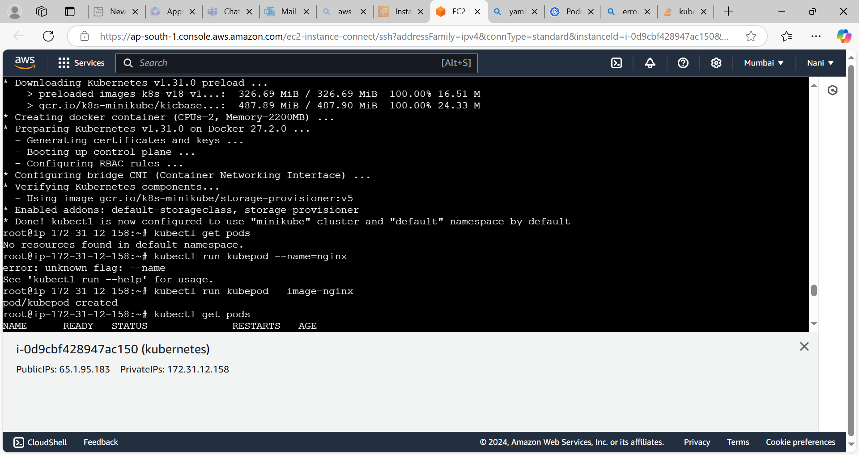

**Declarative method:**

In this method we have to write the yaml file.create the file with extention of yml like vi filename.yml.

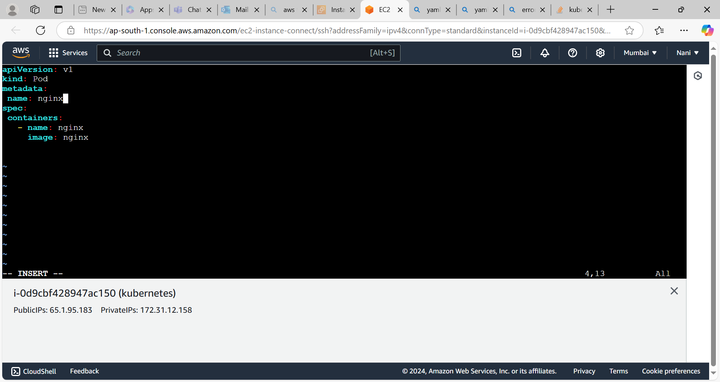

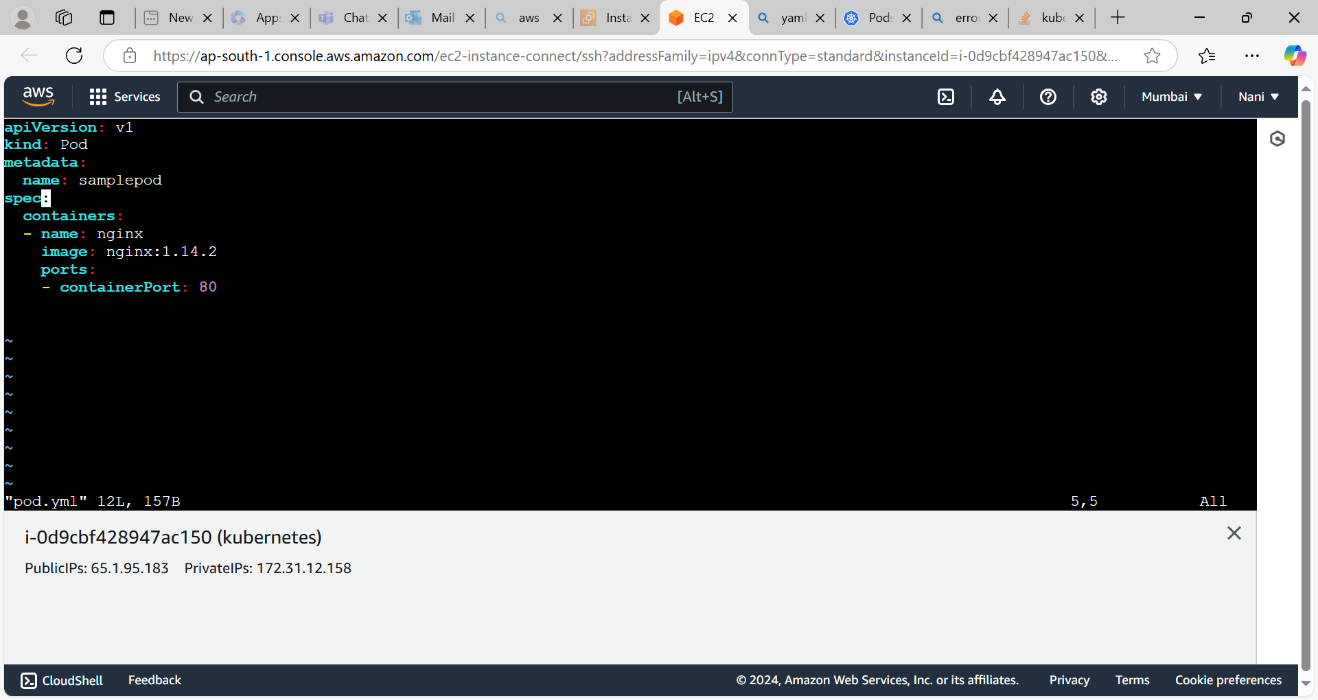

Pods are in running state

